

“The radio station that leaves no listener behind”
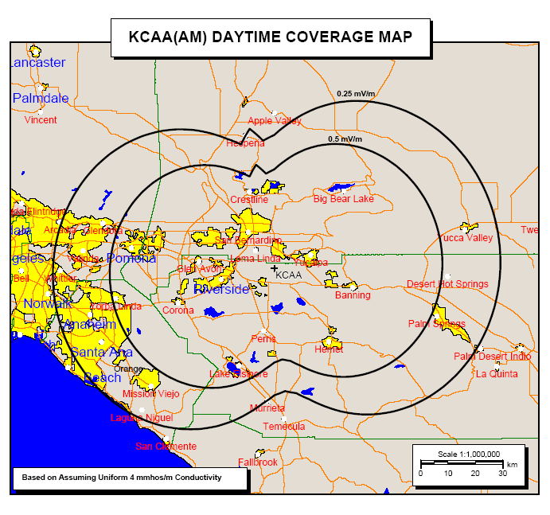
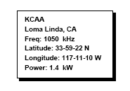
Broadcasting from studios located at 254 Carousel Mall, San Bernardino, Ca. 92401
Transmitter located at 28899 San Timoteo Canyon Road Redlands, California 92373
Send mail to KCAA Radio
Box 1687
Loma Linda, CA 92354
Studio (909) 885-8502 Cell (909) 261-5408
kcaa1050am@earthlink.net
Licensed to Broadcast Management Services, Inc
Fred Lundgren, President

“The radio station that leaves no listener behind”
P.O. Box 1687
Loma Linda, California 92354
(909) 885-8502

Fax (909) 381-8935
kcaa1050am@earthlink.net

CONTACT:

Daren Lane, GM

KCAA Radio

909 261-5408

New radio station comes to the Inland Empire

A new radio station can be heard across the Inland Empire, KCAA 1050 AM, Loma Linda. The station was originally located at Big Bear Lake and formerly known as KBBV AM, “the Voice of Big Bear Valley”.

KCAA offers listeners a unique blend of news and talk shows. KCAA is the NBC and CNBC news Affiliate for the Inland Empire. KCAA is also affiliated with Westwood One, Liberty Broadcasting, Air-America and the Genesis Radio Network. KCAA’s weekday line-up includes well known personalities such as Don Imus, G. Gordon Liddy, Alex Jones, Chuck Harder, Randi Rhodes, the Rev. Barry W. Lynn Fred Wallin’s “Scores and Odds”, Nick La Capria’s “Sports Nuts”, Al Franken and Linda Salvin’s “Visions and Solutions”.

KCAA’s weekday line-up is enhanced with NBC National News weekdays every hour and CNN News weekends. National news personalities include Tom Brokaw, Brian Williams, and Ann Curry. Hourly local newscasts are delivered seven days a week by veteran Inland Empire newscasters, Dennis Baxter, Lacey Kendall and Ray Peyton with editorials by KCAA General Manager, Daren Lane.

KCAA broadcasts a variety of short features such a “Biography For Radio” by Jack Perkins, Jim Hightower’s daily “Low Down”, Nick La Capria’s “Sports Quiz” and Chef Piero Biondi’s recipe minute.

Weekend programming offers a full spectrum of local and national talk shows ranging from programs about auto repair, cooking, computers and world finance. KCAA even has a about beer!

KCAA’s unique programming mix lives up to its slogan, “The radio station that leaves no listener behind”.

End
BROADCAST MANAGEMENT SERVICES INC
KCAA RADIO 1050 AM

Post Office Box 1687
Loma Linda, CA 92354
(909) 885-8502 Voice (909) 261-5408 Cell (909) 381-8935 Fax
kcaa1050am@earthlink.net

CONTRACT

TYPE OF BROADCAST: 60____ 30____ News____Program____Other___

Rate ______________ Start Date ______

Total ______________ End Date ______
Special Instructions____________________________________________________________________________

_______New Contract _______Renewal _______Revision

SCHEDULE
Week of | Monday | Tuesday | Wednesday | Thursday | Friday | Saturday | Sunday
Advertisers who pay in advance of all broadcasts will receive a 10% discount. Failure to pay as agreed may result in contract cancellation. Station reserves right to cancel or reschedule in case of power or equipment failure beyond the station’s control or national, regional or local emergency.

Authorized By KCAA Authorized By Advertiser___ or Rep___

Signature___________________________ Signature___________________________
Date_____________ Date_____________

ADVERTISER – COMPANY NAME_______________________________________ ADDRESS______________________________________________________________CITY_______________________________State__________________Zip__________

Phone_________________________________

Fax___________________________________

Email_________________________________

KCAA 1050 AM

DAREN LANE IS MANAGING TO BUILD

A BETTER RADIO STATION
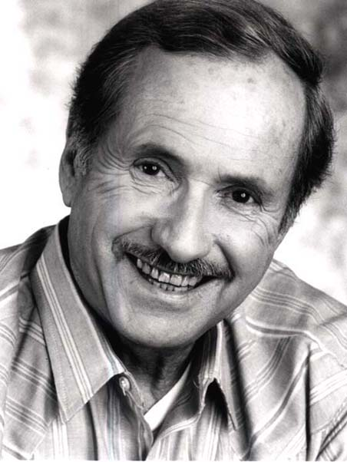
DAREN LANE

KCAA GENERAL MANAGER

DAREN LANE HAS DECADES OF BROADCAST EXPERIENCE, FROM JANITOR TO GENERAL MANAGER, FROM TALK SHOW HOST TO NEWS AND PUBLIC AFFAIRS DIRECTOR.

Daren fondly recalls the thrills of interviewing the Beatles on their arrival in San Francisco, traveling with and interviewing both Democratic and Republican Presidents and Presidential candidates and covering Presidential Conventions.

Daren has interviewed countless movie stars and has appeared in over fifty movies and music videos. Lane has worked with such radio luminaries as Casey Kasem, The Real Don Steele and, Robert W. Morgan.

While News Director at KEWB in San Francisco, Lane was often rated number one radio newsman in the bay area.

Daren Lane brings his vast experience to KCAA with a vow to make it a major voice in the Inland Empire and beyond. Lane notes "we have found a niche that is missing in this market and we are committed to local news coverage on a level not heard in the Inland Empire in some time.”

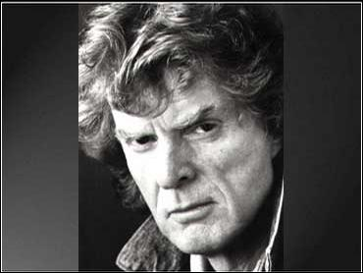

DON IMUS

Start your day with Don Imus from 6 to 9 A.M. weekdays at 1050 KCAA. Now widely acclaimed, Imus has been featured on NBC’s “Today” show, the ABC programs “Prime Time Live” and “20/20,” and on CBS’ “48 Hours” and “60 Minutes.” He has been a guest of Charlie Rose, David Letterman, and Larry King. Time magazine once named Don one of the 25 most influential people in America. More recently, Don appeared on the cover of Newsweek magazine in a feature article titled, “The Importance of Being Imus”.

Don is a mystery. He is also old; very old! Some say Don’s birth occurred in the late 18-hundreds which makes him a contemporary of such noted Americans as Ulysses S. Grant, Rutherford B. Hayes, Chester A. Arthur and Grover Cleveland... all U.S. Presidents.

Most historians agree that Don spent the normal twelve years in public school but emerged with no formal education ... a product of social promotion. He graduated with no honors and no skills. According to many, a successful career in radio requires no skills so radio seemed a natural career path for the young Imus and advancements came quickly.

G. GORDON LIDDY

" The G Man"

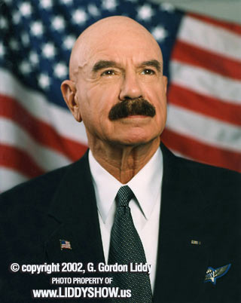

G. Gordon Liddy

Mr. G. Gordon Liddy is the host of THE G. GORDON LIDDY SHOW, his 170 market nationally syndicated radio program celebrated eleven years in February 2003. Mr. Liddy is the author of four best-sellers and numerous magazine articles, and is an actor in motion pictures and television; most recently, a co-star of "18 Wheels of Justice" a weekly television series on The National Network. Mr. Liddy was awarded Israeli paratrooper wings after training in Israel and jumping with the elite IDF parachute regiment in 1993 and jumped with them again in October 2001 and January 2003. He is a member of the Honor Legion of the Police Department of the City of New York and, according to The Wall Street Journal, is "one of the most sought after speakers in the nation."

Listen to G. Gordon Liddy Monday through Friday, 9 to 10 AM, on the Station that leaves no listener behind, KCAA 1050AM.

ALEX JONES
HIGHLY RESPECTED AND HIGHLY DOUBTED WITH A REPUTATION TO MATCH

Alex Jones

Broadcasting from his “bunker” in Austin, Texas, Alex Jones tells it like he sees it." His straight talk "takes no prisoners" approach has earned him a reputation as radio’s conspiracy theorist.

Skeptics call “The Alex Jones Show” a daytime version of ART BELL on steroids, except Alex claims to know the origin of all those UFO’s. According to Alex, they are actually Black helicopters, owned and operated by the new world order and they are coming to take away our freedoms!

Regardless, Alex Jones exposes the Bohemian Grove resort, the secrets of Skull and Bones, The world power of Carlyle Group, the goals of the Trilateral Commission and much more.

According to Jones, American citizens face a growing police state and the current road to tyranny must be re-routed, beginning with the repeal of The Patriot Act.

A strong critic of both Democratic and republican administrations, Jones listeners will be fed a daily dose of alternative theories about 9/11 and a possible Government cover up.

We have all heard the old saying, “Where there is smoke, there must be fire”. Listen and you decide…. each weekday from 10 to 11 AM on KCAA The station that leaves no listener behind!

CHUCK HARDER IS
A TRUE RADIO VETERAN
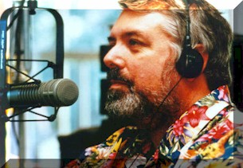
Chuck Harder
Chuck Harder has been involved in radio since the early days of the fabled Gordon McClendon.

Chuck Harder tells it like it is with his “For the People” program carried over the his “People’s Network.” Chuck keeps it real with his analysis of international trade policy and his frank discussion about the exportation of jobs and the problems with unfair trade policies.

Recently, Chuck organized a new satellite television network which broadcasts on Satellite AMC 4 Transponder 6. This network is the latest addition to the “Free To Air Television Satellite System” which competes for viewers with Dish and Direct TV subscribers but requires no subscription fees.

In addition to “Free to Air Satellite TV”, Chuck’s TV network has paved the way for KCAA and other local stations to become “Super stations” by broadcasting on numerous audio channels available on the transponder.

On April 1st, 2004, KCAA began broadcasting on AMC 4 Transponder 6 Audio channel 4 left making KCAA available to over 1 million listeners from Alaska to South America and from Hawaii to the coast of England.

Harder offers mobile and portable satellite radios for $99.00 that will make KCAA available in autos and homes across America WITHOUT A MONTHLY SUBCRIPTION FEE. This will make KCAA coverage and availability comparable to Sirius and XM radio but again, KCAA WILL BE “FREE TO AIR”.

Chuck Harder is heard on KCAA Mon-Fri. from 11 AM to noon.

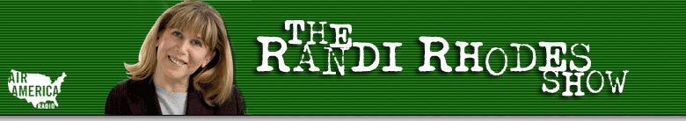

This smoky-voiced Brooklyn native with the lightening fast wit cracks the mic and legions listen. One of the country’s first female entertainment and political talk show hosts, Randi has a passion for people.

Her radio talk shows are legendary in South Florida where she has been the comic relief and the pillar of reality when she gives herself to ideas that people rarely express out loud. Her unflinching candor and self-deprecating approach to life have earned her respect and loyalty. Her ability to research complex ideas and present them simply makes her show very entertaining.

It seems that Randi’s opinion was the one you never knew was yours until you listened to her program. Randi holds nothing back. Randi’s life is an open book and people tune in to hear the pages turn.

Her odyssey started in Seminole, Texas where she was a waitress in a Mexican restaurant to support her radio habit. She made it to New York, Dallas, and Milwaukee before settling in South Florida (WIOD-Miami) and currently West Palm Beach (WJNO).

Randi was also voted ‘Most Outstanding Woman’ in the Air Force in 1979 and won the American Women in Radio and Television Award for ‘Best Entertainment Programming’. During her acceptance speech she thanked her gynecologist and plastic surgeon before adding, “I want a stinkin’ syndication deal… Thank you.”

Randi Rhodes can be heard weekdays on KCAA from Noon to 2 PM. The Randi Rhodes Show is syndicated by the Air-America Radio Network.

A TIRELESS CAMPAIGNER
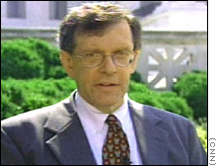
BARRY LYNN

Barry Lynn’s “Culture Shocks” debuted on KCAA on the afternoon of June 25th 2003, the first day KCAA began broadcasting from the Inland Empire after the move from Big Bear Lake, California.

Barry Lynn is a United Church of Christ ordained Minister. He is an activist and lawyer in the civil liberties field dedicated to maintaining the separation of Church and State. His secular program called “Culture Shocks,” makes strong arguments regarding the need to maintain the separation of church and state while always airing apposing views.

Mr. Lynn advocates the separation of church and state to ensure religious and philosophical freedom for all Americans. According to Lynn, Church-state separation does not mean hostility toward religion. Rather, it means the government will remain neutral on religious questions, leaving decisions about God, faith, houses of worship and attendance in the hands of its citizens.

Mr. Lynn asserts that religious liberty cannot flourish when government tries to enforce a state version of religious orthodoxy. Such policies always foster religious repression. By contrast, religious liberty has flourished in America because the constitution prevents the Government from demanding citizens to adhere to chosen faiths.

Culture Shocks is syndicated on the Genesis Communications Network and is heard on dozens of stations around America.

Join Barry Lynn, his guests and callers Monday-Friday from 2 to 3 P.M. on KCAA.

Fred Wallin Co-Host of Scores and Odds
Weekdays 3 to 4 PM on KCAA

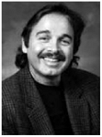
Fred Wallin

Fred Wallin is a veteran of the sportstalk wars, both locally in Southern California and nationally. Wallin has hosted ''Dodger Talk," "Angel Talk," "Kings Talk," and "Bruins Talk" on various Southern California radio stations.
Wallin hosted programs on KABC, KFI, KLAC, KIEV, KFOX AND 1150 AM in Los Angeles.
Nationally, Wallin has hosted programs on The Sports Radio Network, The American Sports Radio Network, Prime Sports, The Sports America Radio Network, and presently on Business Talk Radio, the Cable Radio Network, and Sports Overnight America.
On the TV side, Wallin was the Baseball expert on ESPN'S Sportslook with Roy Firestone for three years...Also, he has made many appearances on Fox Sports Net's "Sports Roundtable" program.
Sports is big business, whether it’s the multi-million dollar contracts signed by the players or the marketing and advertising behind the teams. Sports fans will be talking to Fred Wallin about the money, events and people that make up the exciting world of sports. Wallin has done various political programs including the "the Ed and Fred" program on KFI radio.

Fred Wallin and the lovely Christina Challey talk sports every weekday from three to 4 PM on KCAA 1050 AM radio.

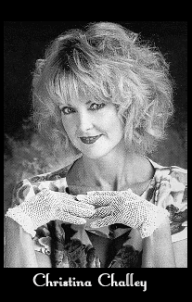
Co-Host of Scores and Odds
A native of California, Christina graduated from the University of California/Berkeley with a double major in Theater/Physical Education. She is a trained exercise instructor, and loves sports activities of all kinds. This love of sports has lead her to one of her favorite roles as an Oakland Raiderette. It also led to her meeting one of Los Angeles’ top sports radio hosts, Fred Wallin.
Christina has worked as a coach with the Los Angeles branch of the Special Olympics. She also works with children, not only reading to them with the SAG “Book Pals” program, but she also teaches them health and fitness through music. She has written and co-produced a children’s musical album dealing with health and safety called, “Starrland”, which contains such songs as “You Are What You Eat”, “The Veggie Song” and “The Water Son”. Christina also produced thirteen musical television episodes of “Starrland – A Futuristic Fairy Tale Land Where It’s Fun to be Safe and Healthy”, which is now airing in Las Vegas.
Christina has hosted a variety of athletic shows and events including a charity golf tournament and sports talk radio shows with Fred Wallin.
Christina plays many sports, but especially enjoys golf, tennis, snow and water skiing.

Sports Nuts Radio Show.com
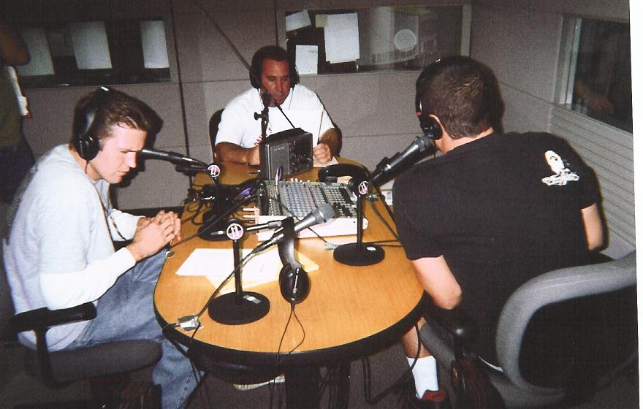
Sportsnuts is the only Locally produced live sports talk program in the Inland Empire. Sportsnuts airs from 4 to 5 PM weekdays and a lighter version of Sportsnuts airs Saturdays from 3-4 P.M.

The program is hosted by "The Sports Encyclopedia", Brian Logan and "Professional Comic" Kenny Frye and includes commentaries by The One and only, “Big Kahuna”. The daily extreme action Sports Update is hosted by Inland Empire Extreme Sports Specalist, Chris Ruskar.

The creator of Sportsnuts, Nick La Capria also makes appearances. The weekday show also features live discussion about the latest news in the World of Sports! The 66 Seconds of Specialized Sports allows listeners an opportunity to hear about many sports not usually at the top of the headlines like Boxing, Minor League Baseball, Golf, Gymnastics, Bowling, Horse Racing, Tennis, Auto Racing, Fishing, etc!

On Friday, The Sportsnuts Showcase Features area High School Football and is hosted by Long time Inland Empire High School Football/ Basketball, and Announcer- Rich Schick (featured on www.HearHsSports.com) The Sportsnuts cover all the bases across the Inland empire and beyond.
Sports Nuts is heard on KCAA 1050 A.M. and in all 50 States on the Web at www.kcaaradio.com or, anywhere in North and Central America on Satellite Radio AMC-4 Transponder 6, Audio 4 Left.

The Al Franken Show
5 to 7 p.m. Weekdays
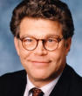
It’s me Al Franken !
Al Franken is an Emmy Award-winning television writer and producer, Grammy-winning comedian, radio host, and best selling author of Liars,…. Rush Limbaugh is a Big Fat Idiot and Other Observations; …..Why Not Me?; …..Oh, the Things I Know!, and….. I'm Good Enough, I'm Smart Enough, and Doggone It, People Like Me! His widely acclaimed liberal talk show debuted on Air-America March 31, 2004.
A 1973 graduate of Harvard, Franken performed stand-up comedy before joining Saturday Night Live. Between 1975 and 1980, Franken won five Emmy Awards, four for writing and one for producing. Franken returned to SNL for a 10-year run in 1985, during which time he created one of the SNL Hall of Fame characters, self-help guru Stuart Smalley.
In 2003, he served as a Fellow with Harvard's Kennedy School of Government at the Shorenstein Center on the Press, Politics, and Public Policy.
Rumors are circulating that Franken, who grew up in Minnesota, may challenge US Senator Norm Coleman for the seat Coleman won following the tragic death of Minnesota Senator Paul Wellstone in October of 2002.
Al Franken lives with his family in New York City. “The Al Franken Show” can be heard from 5 to 7 p.m. weekdays on KCAA.



For the first time in the history of network radio news, newscasts are fully anchored by top television news talent. Anchored by NBC and MSNBC news anchors and reporters, including Tom Brokaw, Brian Williams and John Seigenthaler, NBC News Radio consists of one-minute weekday news reports, one-minute special reports during breaking events news and simulcasts of breaking news events form NBC-TV and MSNBC-TV.
Local newscasts are anchored by veteran newscaster and KCAA General Manager, Daren Lane Flickinger.

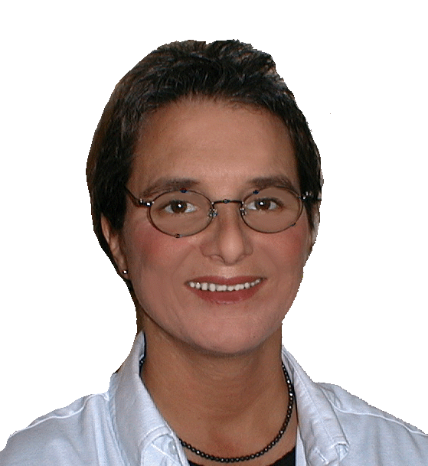
Program Director

Lacey Kendall

Lacey Kendall has been a vital part of Inland Empire radio for over twenty years. Her career started at KVCR-FM and she has worked as DJ, news reporter, announcer, and "charge d' fare….on air" at almost every station in the Valley. Her broadcast talents bring a whole new dimension to the KCAA Broadcast day. We are very pleased to have Lacey as a part of our KCAA family.

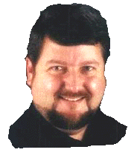
Production Director
Ray Peyton
Ray Peyton brings three decades of broadcast experience to KCAA. As a disc jockey, talk host, voice-over actor and newsman on both radio and TV, Ray's been heard on more than 800 stations across the country.
A man of many talents, Ray has perfected over 60 unique voices ranging from KCAA’s “Captain Vern” to well known national personalities like “Wolfman Jack”and Richard Nixon.
Over the years, Ray’s talents have been heard on several Inland Empire stations in addition to stints in San Diego and the legendary KRLA - 1110 AM in Los Angeles. Ray is also the “in-house” voice of a large supermarket chain in California.
Ray anchors afternoon drive at KCAA. Everyone at KCAA is excited to have Ray Peyton on the team.

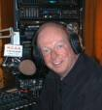
News and Public Affairs

Dennis Baxter

Broadcaster Dennis Baxter joins KCAA 1050 with a list of credits that can fill a volume.

Dennis was born and raised in the Inland Empire and graduated from San Bernardino Valley College with a broadcasting major. After college, he worked the morning drive shift at various area radio stations including KRNO, KBON, and KPRO.

Baxter left the Inland Empire when Tribune Broadcasting Corporation offered him the news director and anchor position at KCTC FM and KGNR AM in Sacramento.

Over a ten-year period, Baxter garnered numerous awards from Associated Press and United Press International, including “Best Newscasts”, “Best Documentary”, and “Best Public Affairs Program” in the state of California.

Dennis Baxter anchors morning drive at KCAA plus he manages KCAA’s News and public affairs department.

Dennis’ distinctive style adds a sense of “urgency” to morning drive that’s unique to Southern California radio.

Dennis is like a great cup of coffee because he gets you ready for the day ahead.

HTOS is on KCAA From 11 AM to 1 PM Saturday
This is HTOS
The core hosts of HTOS have been together for over two years. The "Fearless Leader" Howard Drescher, Miesha "The Right One" Wright, and Nick "Sights and Sounds" Anthony all graduated from the Academy of Radio and Television Broadcasting and Lee "No Nickname" Harmon graduated from the Radio department at Cerritos College. The Fifth member of the group is Mike "the Perry Mason of Radio" Duarte and he is a practicing attorney. Don't ask him for legal advice on the air because he is still practicing.
Everybody has a job to do on HTOS. Howard tells us when the commercials starts and ends. Lee has his headlines from the strange and wonderful world beyond the Inland Empire. Nick plays the music and argues with everyone, Miesha answers the phones and yells at the guys to behave when they get out of line. Mike……. well they don't know what he does, but he does it very well.
But what does HTOS stand for? It used to mean "Hot Talk on Sports". But they didn't want to be stuck just talking about sports. So maybe it means "Hot Talk on Stuff"? Maybe…… but I think it means "Hey This is Our Show". Now that's original!
HTOS is like must see TV except it's on the radio, so to get it you must dial in to 1050AM on your dial every Saturday from 11AM to 1PM.

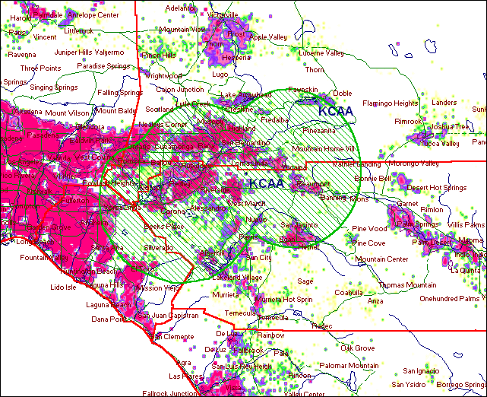
KCAA RADIO 1050 AM Loma Linda, California
Monthly price for a 30 sec spot every other hour………………………………….$500.00
Monthly price for a 60 sec spot every other hour………………………………….$750.00

Monthly price for a 30 sec spot every hour………………………$1,000.00
Monthly price for a 60 sec spot every hour………………………..1,500.00

Monthly price to sponsor one weekday newscast each weekday…………………2,200.00
This package includes two 60 sec spots during the newscast plus one 60 sec spot each hour.

